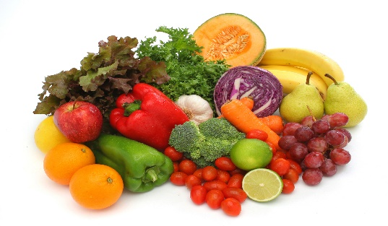
GUESS THE WEIGHT
When talking about food, we often hear the word ‘portion’. This means the amount or size of the food we are eating.
The government recommends that we eat 5 portions of fruit and vegetables a day and each portion should be 80g or enough to fit in the palm of your hand.
But do we know what a portion actually looks like?
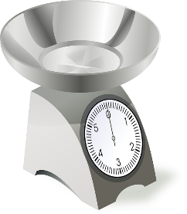
Have a go!
Choose 5 different fruits and vegetables (or more if you like!)
Guess the weight of each of them and record under ‘estimated weight’.
Weigh them carefully and write the amounts under ‘actual weight’.
How close were you? Work out the difference between the two numbers.

Name of Fruit or Vegetable | Estimated Weight | Actual Weight | Difference  ( + or - )
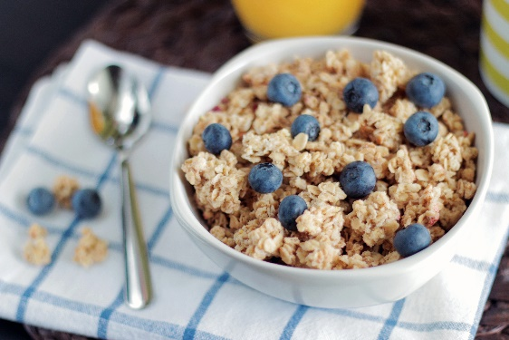
Cereal Challenge!
The next time you eat a bowl of cereal, have a look on the packet to see how much a serving size should be. It is normally about 30 grams.
Weigh the amount that you normally put into your bowl and see how close you are to the recommended serving size. You may be surprised! The amount you have can mean that you may be eating a lot more sugar than you think.
Information and ideas about how to get your 5-a-day can be found here:
https://www.phunkyfoods.co.uk/wp-content/uploads/2019/05/Strive-for-5_PRINT.pdf
GUESS THE WEIGHT
When talking about food, we often hear the word ‘portion’. This means the amount or size of the food we are eating.
The government recommends that we eat 5 portions of fruit and vegetables a day and each portion should be 80g or enough to fit in the palm of your hand.
But do we know what a portion actually looks like?
Have a go!
Choose 5 different fruits and vegetables (or more if you like!)
Guess the weight of each of them and record under ‘estimated weight’.
Weigh them carefully and write the amounts under ‘actual weight’.
How close were you? Write down if your guess was more or less.
Name of Fruit or Vegetable | Estimated Weight | Actual Weight | Was my guess more or less?

