Double a Smoothie
https://www.phunkyfoods.co.uk/recipe/get-up-go-smoothie/
Smoothies are a healthy and easy way to start the day. You could make one for all the family!
The ingredients for a ‘Get up and Go’ smoothie on our website make enough for two people. If you wanted four people to try it then you can double the amounts.

Ingredients for 2 people | Ingredients for 4 people
100g low fat natural yoghurt
200ml semi skimmed milk
1 large banana
1 wheat biscuit
½ teaspoon cocoa powder

Method

Pour the milk into the measuring jug and then add all the other ingredients.
Blend until smooth. Serve in glasses with an extra dusting of cocoa powder on top.

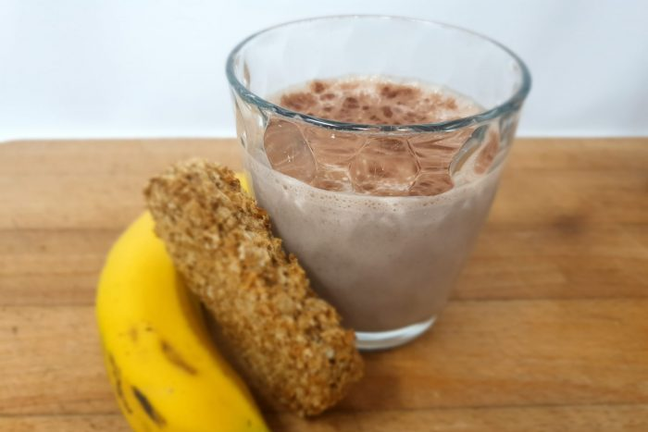

Doubling Oats

https://www.phunkyfoods.co.uk/recipe/overnight-oats/

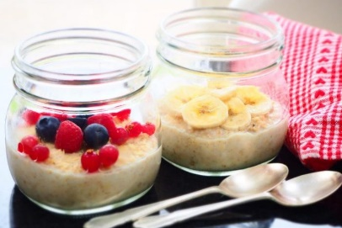
Overnight Oats are a great and easy breakfast that can be made
the night before.

Our website has ingredients for 1 portion. However, if you want
someone else to taste how delicious they are, you will need to
double the ingredients.
Complete the tables below – be careful with the second one, it has fractions!
Ingredients for 1 portion of  Very Berry Overnight Oats | Ingredients for 2 portions

50g rolled oats

100ml semi skimmed milk

50ml Greek Yoghurt

1 tablespoon of mixes berries
Method
Divide and pour the oats into jam jars.
Add the milk and yogurt and mix well.
Seal and refrigerate overnight.
Warm in the microwave, add a splash of milk if necessary and place the berries on top.
Ingredients for 1 portion of  Carrot Cake Overnight Oats | Ingredients for 2 portions

50g rolled oats

150ml semi skimmed milk

¼ teaspoon vanilla essence

¼ teaspoon cinnamon

1 tablespoon of grated raw carrot

½ tablespoon of raisins

Method
Divide and pour the oats into jam jars.
Add the vanilla essence and cinnamon to the milk, and pour into the jam jars.
Add the carrot and raisins and mix well.
Seal and refrigerate overnight.
Halving Space Rocks
https://www.phunkyfoods.co.uk/recipe/space-rocks/
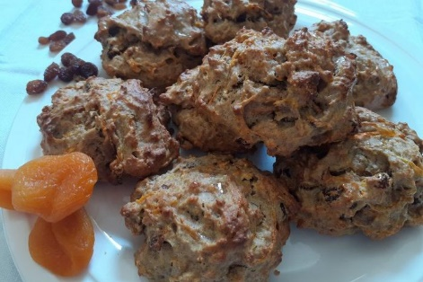
Here’s a delicious recipe for Space Rocks, a healthy snack that
contains fruit and a vegetable!
The recipe is for 12 people but what if you only wanted to make 6 of them? You would need to halve the amounts.
Find half of each ingredient and create a new list in the table below.
Note: Can you easily halve a raw egg? Instead of a large egg how about using a medium size one?
Ingredients for 12 rocks | Ingredients for 6 rocks
3 wheat biscuits
180g self raising flour
1 teaspoon cinnamon
40g sultanas
40g dried apricots
1 tablespoon sunflower seeds
80 ml vegetable oil
2 small bananas
1 large egg
1 large carrot
1 tablespoon clear honey
Method
Pre-heat the oven to 200C / gas mark 6 and brush the baking sheet with oil and cover with baking parchment paper.
Cut the apricots into small pieces. Peel and grate the carrot.
Place the wheat biscuits in the bowl and crush with your hands to break the biscuits into crumbs.
Add the flour, cinnamon, dried fruit and seeds. Stir well.
Put the bananas, egg, honey and vegetable oil into a jug and use a hand blender to blend until smooth. Pour into the mixing bowl, add the grated carrot and stir everything together.
Use a tablespoon to create 6 or 12 mounds of the mixture on the lined baking sheet (around 2 heaped tablespoons of mixture per mound).
Bake in the preheated oven for around 15-20 minutes until the ‘rocks’ have risen and are golden brown.
Drizzle a little honey over the top of the warm cakes, and leave them on the baking sheet for a few minutes to cool slightly. Once cool enough to handle, transfer to a wire cooling rack.
Space rocks are delicious eaten while still warm! Once completely cool, transfer any uneaten ‘rocks’ to a freezer bag and freeze.

