Dancing Raisins Experiment
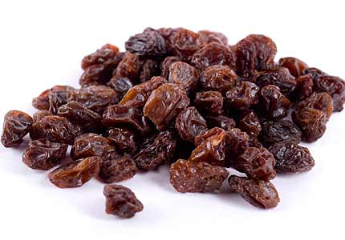
Raisins are a great snack and count towards your five a day.
They can also be added to cakes and biscuits to provide natural sweetness. Raisins are actually dehydrated grapes, but when you add a certain liquid to them, they become little dancers. Or at least that's how they look!
To demonstrate the principles of density and buoyancy, all you need is a little carbon dioxide gas. To create carbon dioxide, you can use baking soda and vinegar or the less messy (and less predictable) clear, carbonated fizzy drink (soda).
You will need:
- 2 to 3 clear glasses (depending on how many versions of the experiment you want to run at the same time)
- A box of raisins
- Clear, well-carbonated soda (tonic water or sprite work well) or baking soda, vinegar, and water
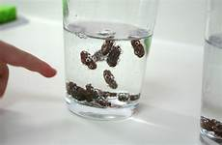
Start by asking the following question: What do you think happens when you put raisins in a fizzy drink?
Decide whether you want to use a fizzy drink or baking soda and vinegar to conduct the experiment or if you want to compare what happens in both versions of the experiment.
Instructions:
- Note: For the baking soda and vinegar version of the experiment, you’ll need to fill the glass halfway with water. Add 1 tablespoon of baking soda, stirring to make sure it dissolves completely. Add enough vinegar to make the glass about three-quarters full, then proceed to Step 3.
- Put out one clear glass for every different type of fizzy drink you’ll be testing. Try different brands and flavours; anything goes so long as you can see the raisins. Make sure your fizzy drink hasn’t gone flat and then fill each glass to the halfway mark.
- Plop a couple of raisins into each glass. Don’t be alarmed if they sink to the bottom; that’s supposed to happen.
- Turn on some dance music and observe the raisins. Soon they should begin dancing their way to the top of the glass.

Observations and Questions to Ask
- What happened when you first dropped the raisins in the glass?
- Why did they sink?
- Once they started "dancing," did the raisins stay at the top?
- What else did you notice happening to the raisins? Did they look different?
- Do you think the same thing would have happened if you put raisins in water?
- What other objects do you think would "dance" in soda?

The Science Part
As you observed the raisins, you should have noticed that they initially sank to the bottom of the glass. That’s due to their density, which is greater than that of liquid. But because raisins have a rough, dented surface, they are filled with air pockets. These air pockets attract the carbon dioxide gas in the liquid, creating the little bubbles you should have observed on the surface of the raisins.
The carbon dioxide bubbles increase the volume of each raisin without raising its mass. When the volume increases and the mass does not, the density of the raisins is lowered. The raisins are now less dense than the surrounding fluid, so they rise to the surface.
At the surface, the carbon dioxide bubbles pop and the raisins’ density changes again. That’s why they sink again. The whole process is repeated, making it look as though the raisins are dancing.

Extension
Try putting the raisins in a jar that has a replaceable lid or directly into a bottle of soda. What happens to the raisins when you put the lid or cap back on? What happens when you take it back off?

(Experiment adapted from https://www.thoughtco.com/)

