Floating Egg Experiment

Eggs are an excellent source of protein, vitamins and minerals. Protein is essential for building and repairing our bodies; our muscles, organs, skin, hair and nails all contain protein.
Can you make an egg float in water? In this simple experiment, it takes just a few minutes to test the laws of density and discover how easy it is to make an egg float. This experiment can be done across year groups depending on how detailed you wish to make it.
You will need:
- 2 Eggs
- 2 Tall Drinking Glasses
- Salt
- Water
- Measuring Spoon

Experiment Set-up
Start with some observations about the eggs. Note that they are both raw eggs and have a similar size and weight. Then ask some questions:
- Do you think that the eggs will sink or float when placed in water?
- Do you think it’s possible to make them float?
- If so, how?
Write down predictions and then follow the steps below.
Step 1
Fill a tall drinking glass about 3/4 full of water and carefully place the egg into the glass.
What happens to the egg? That’s right, it sinks to the bottom.

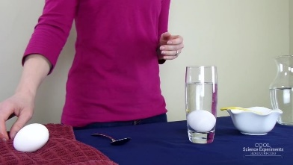
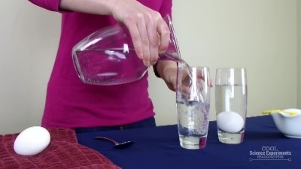
Step 2
Fill another tall drinking glass about 3/4 full of water.

Step 3
Add 3 Tablespoons of salt to the water and stir until it is completely combined. What do you think will happen if you place the egg into the glass with the salt water? Write down your prediction and then test it to see if you were right.

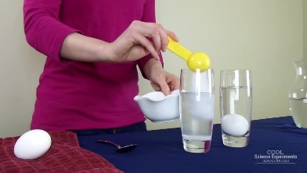
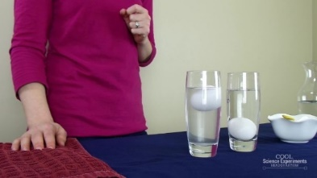
Step 4
Next carefully place the second egg into the glass with the salt water. What happens to the egg? That’s right, it floats. Take a moment to make some observations. Why do you think one egg sinks and the other egg floats?

How Does the Floating Egg Science Experiment Work?
Why does the egg sink in regular tap water, but float in salt water? The answer lies in the density of water!
Density is about particles and how tightly packed they are. Water has a density of 1 g/mL (g/cm3). Objects will float in water if their density is less than 1 g/ml. Objects will sink in water if their density is greater than 1 g/ml.
Therefore, if you put an object in water and it floats, it shows that it is less dense than the water. Or, if the object sinks it shows that it is denser than the water. The egg will sink in regular tap water because the density of the egg is greater than the density of water. The egg’s density is only slightly higher than water at 1.03 g/ml, but that is enough to make the egg sink.
When you add salt to the water, you are increasing the density of the water by adding more mass (or stuff) in the given volume. You don’t really change the volume of the water by adding salt. By adding enough salt, you increase the density of the water so that it is higher than the density of the egg and the egg will float!

Other Ideas to Try
Try this experiment again, but instead of using an egg use a potato slice or a carrot slice. You will have to play around with the amount of salt you add to the water because all objects have their own unique density.
Add salt a tablespoon at a time and mix well until you cannot see any salt in the solution, then add your object to see if it floats or sinks.
Remove your object and keep adding salt until you can get your object to float. To make it a true science experiment, create a data table to keep track of how much salt you add to the solution.
(Experiment and images from https://coolscienceexperimentshq.com)

