Egg Shells Tooth Decay Experiment
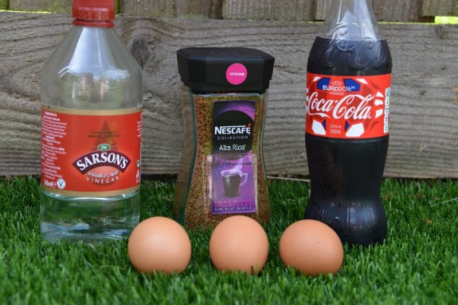
We all like to have a happy and healthy smile! This fun experiment with egg shells is all about teeth and how to keep them healthy. Sugary, sticky food is not good for teeth as it sticks to their surface. Plaque and acid are then formed by bacteria feeding on the sugar. Cleaning teeth twice a day helps keep teeth and gums free from plaque.
Did you know that eating cheese at the end of a meal can help neutralise the acids in your mouth and reduce the chance of tooth decay?
We can’t experiment on our own teeth so are using eggs to represent them, as the shell of an egg is made of a similar substance to tooth enamel.
You will need:
Eggs
Jars
Water
Tea/Coffee
Fizzy flavoured drink
Vinegar
Toothpaste
Instructions
- Pour the same amount of fizzy drink, vinegar, water and tea or coffee into your jars.
- Add a whole raw egg still in its shell to each, cover an extra egg with toothpaste and also place in tea/coffee.
- Leave for approximately three days.
- Remove the eggs.
- Rinse the egg kept in vinegar and rub gently until the shell comes away.
Results
You should see staining on both the fizzy drink and tea/coffee egg.
The toothpaste covered egg should stain less than the non-toothpaste covered egg
The acid in the vinegar should completely dissolve the egg shell, leaving just the membrane.
(Experiment adapted from www.sciencesparks.com)

