Get Active Email Snippets
- Your child’s 60 minutes of exercise doesn’t need to be carried out all in one go to benefit their health
- Shorter bouts of energy at different times during the day all count towards the 60 minutes of physical activity
- They could do short 10 minute sessions of different activities throughout the day. These can include walking or cycling to school, running around in the playground and any afterschool activities such as swimming.
- Any bodily activity that enhances or maintains physical fitness and overall health and wellness.
- This includes walking up and down stairs, brisk walking, gardening, playing outside, dancing, skateboarding, basketball, netball and running

- Sedentary behaviour is any time a person is sitting or lying down.
- This includes watching TV, computer use - playing video games, driving and reading.
- All children and young people should minimise the amount of time spent being sedentary for extended periods of time.
- Evidence suggests that activities such as watching TV are often associated with negative eating habits, including the consumption of energy dense food and drinks.
- Gardening, lawn mowing and outdoor work are a great way to get active outdoors.
- Let your kids help you out with planting seeds, fetching you equipment, or any other DIY jobs going on outside.
- When the weather is nice, the garden is the perfect place for ball games and activities. No garden? Why not go to a local park or community garden.

- Use platforms such as YouTube for some free, instructor led exercise. Go for a low or moderate intensity workout that you can complete with your kids.
- There are plenty of videos available to suit everyone depending on how much time, space or equipment you have!
- Incorporate these into your evening routine, it doesn’t have to take up all of your time and can be a bit of fun.
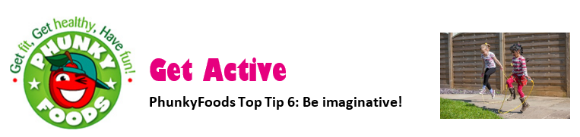

- Why not devise your own obstacle course from everyday household items, such as cushions, pillows, blankets, clothes horse and large cardboard boxes etc. This can be done indoors or outdoors.
- Time each other when it is completed and have a competition
- Can your children create their own obstacle combinations?

- Get active by dancing and singing along to all your favourite songs.
- Dancing is a great form of exercise and you can do it anywhere with anyone.
- It’s a great way to burn some energy and its loads of fun!

- Too much time sitting down looking at screens can be a risk to your child’s health, including becoming overweight and/or obese.
- Swap some of that screen time for some exercise.
- Encourage participation in house chores such as setting the table or taking the bins out.
- Choose toys such as a scooter, skateboard, and ball or kite to encourage active play.
- Join in their games and play or exercise with your children.
- They love it when you take part in activities with them and are more likely to do it themselves if they see those around them regularly doing exercise.
- You can help them learn a new sport or physical activity, this can make it feel less daunting knowing they aren’t doing it alone.

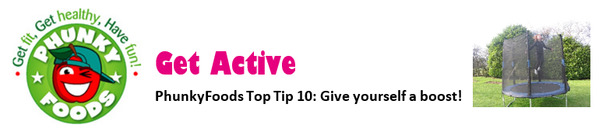
- Exercise should never be a punishment or a chore. It should make you and your family feel happy and refreshed.
- Some children are so overloaded with homework, music lessons and other planned activities. Physical activity can be used as a break from this to relax and recharge. Even if it is just going for a brisk walk or playing outside.

