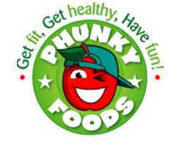
Early Years/ KS1 Activity Ideas

- Look at different food packaging and discuss their appearance.
- Early Years: What colours are they? What shapes are they? Is one bigger or smaller than another?
- KS1: How many sides and corners does it have? Is it a 2D or 3D shape?

- Sing 1 Potato, 2 Potatoes or 10 green bottles song to encourage counting and sequencing of numbers. Ask the children to count along using their hands or use physical props to help them visualise it.

- Role play- Set up an area of the classroom to use as a greengrocer shop. Use either food packaging or plastic food items for the children to sell and buy.
- KS1: Use plastic coins to help them recognise the value of different coins such as 1p, 2p and 5p. Can they add two coins together?

- The children can complete a sorting activity with plastic/wooden food items into different colours or sizes. Prompt using language such as larger or smaller.

