Halving and Doubling a Recipe
Oat and Yoghurt Muffins
https://www.phunkyfoods.co.uk/recipe/oat-and-yogurt-muffins/
The oats and yogurt in these muffins give them a different texture and make them a great choice for breakfast or at any other time.
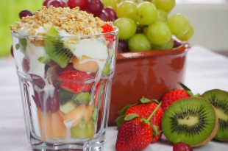
The ingredients for ‘Oat and Yoghurt Muffins’ on our website make enough for twelve people. If you wanted six people to try it then you can halve the amounts.
Ingredients to make 12: | Ingredients to make 6:
200 g plain flour
1 ½ tsp baking powder
85g rolled oats
240 ml
1 tsp bicarbonate of soda
1 egg
100 g light brown sugar
110 ml semi-skimmed milk
90 ml vegetable oil
140 g berries

Supercrunch
https://www.phunkyfoods.co.uk/recipe/supercrunch-cold-pudding/
Supercrunch is a cold pudding which can be put together in minutes! It’s great to have as a breakfast, a snack pot or a pudding!
The ingredients for ‘Supercrunch’ on our website make enough for two people. If you wanted four people to try it then you can double the amounts.
Ingredients to make 2: | Ingredients to make 4:
160 g fresh fruit
150 g plain low fat yoghurt
1 tsp runny honey
50 g oat cereal / granola

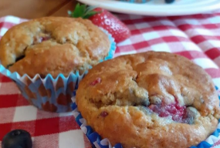
Try getting hands on and weighing out some of these amounts. Can children estimate the weight of different ingredients?

